This document will record all the strats used in the Pokemon Red - Any% Glitchless (Nido Route) Blindfolded Speedrun. By Bubzia.

# Table of Contents

**Abbreviations** **2**

**Before the run** **2**

**Splits** **2**

Nido 3

Brook (Gym1) 4

Route3 5

Mt Moon 6

Nugget Bridge 7

Misty (Gym2) 10

Surge(Gym3) 11

Rocktunnel 15

Fly 18

Pokeflute 19

Silph Co. 21

SafariZone 23

Koga (Gym4) 24

Erika (Gym5) 27

Blaine (Gym6) 27

Sabrina (Gym7) 28

Giovanni (Gym8) 28

Elite 4 29

Victory Road 30

Lorelei 31

Bruno 32

Agatha 32

Lance 33

Champ 33

**Notes** **34**

# Abbreviations

tb = Textbox (Soundwise)

U = Up

D = Down

L = Left

R = Right

B after U,D,L,R = holding that direction will result in a wall sound

J after U,D,L,R = holding that direction will result in a jump sound

SQ = save+quit (hardreset)

HA = Hornattack

PS = Poison Sting

IT = Instanttext

BB = Bubblebeam

TB = Thunderbolt

HD = Horn Drill

EQ = Earthquake

# Before the run

* If using emu must show a hard reset before starting a new game
* Clear saved data before starting by pressing Up + B + Select
* Set game options: Text speed = fast, Battle animations = off, Battle style = shift

# Splits

## Nido

15tb into start (name own character “A”)

7tb (name rival “A”)

Mash till fadeout music

2RB,5UB,2RB into stairs

6DB,4L,D into exit

5R, UB into cutscene

Mash text

14tb after entering house

D, 2R,U, A mash till get sound, (squirtle)

3A,start (nickname: A)

mash till Rival get sound

DB,2L,DB into mash text for fight

### Rival

Bulbasaur: tailwhip into mash A for tackle the whole fight

Mash text into rival leave music - hold D during music till exit house

3L,10UB,R,10UB,2L, 4UB, 4R, 4UB,3L, 6UB, 5R, 12UB, 3L, 8UB

2L, 10U, 10R, U into shop

Mash text till parcel get, mash text hold 2D till B,R,D into exit

L, 7DJ,2DB, 8L, 8D, 2L, 3DJ, 3DJ,3DJ,2D,9RB,2DJ,3DJ,2D,7L,DJ ,15DB

L, 5D, 3R, U into house

UB mash A, mash text, after rival leave music starts hold D till exit house

3L,10UB,R, 10UB,2L, 4UB, 4R, 4UB,3L, 6UB, 5R, 12UB, 3L, 8UB

//kill at least 1 enemy till this point in grass for exp (bubble for brook)

2L, 10U, 10R, U into shop

2U,L,3A(delayed, first A no sound),7U,A till buy sound into mash B (buy 8 pokeballs)

2DB,R,DB exit shop

15L,3UB,7L into save SQ

### NidoManip

* <https://www.youtube.com/watch?v=_IMIxCrx3vk> (Lv4 15/11/14/14)

Hold Select+up+b 3s after gameboy sound //fadeout headphone initialize sound

Release right before first music note into

Instant hold start right before pokemon title drop sound

Hold A after squirtles cry

Wait for confirm sound start count till 4 in 190bpm hold left

Right at 1|2|2.5 in music

Start beatcounting quaters

Left at 1|2|2.5

Down at 5

Left at 7

Up at 8.25 start back at 1

Down at 10.5

Catch it (just throw balls at it, you need preferably more than 3 left so reset after 5 throws)

4tb after pokedex cry (name it “A”), start

## Brook (Gym1)

2D,4RB,3U,19RB, U,2R, 12U (trainer can get in your way) , LB mash A for secret potion

MENU: item-potion(1down)-3A for squirtle

2R,UB,3L,5U,6R,8UB,7L,UB into house

R,7UB into forest

### Forest

4UB,9R,9U,LB,2U,2R,12U,2LB, 8UB mash A for antidote, 3U, 8L, 7D, 4L, 13U,

6L,DB, LB,

MENU: SAVE

6U, A for secret potion, U into Battle

**Bug Catcher:**

2xtailwhip into mash tackle (heal with potion if redbar, if you die just walk back or reset)

//squirtle learns bubble

After battle: 19UB into exit

Check for poison after 4U, Menu: potion on squirtle, (antidote on squirtle OR toss antidote if not poisoned(5A for toss),

swap squirtle with nidoran!!! Pokemon-squirtle-down swap- down nido exit menu

R,7UB into exit

3U,5R, 22UB,R,9U,9L,5D,6R,UB into GYM

5U,3LB,4UB,3R,2UB, SAVE(should be 3 down from pokemon)

MENU: Option(should be 1 down from save)-D,L, (battle animations on) //to check for bide

Mash A for fight(menu should be still on pokemon if everything done right)

### Brook(Gym1):

Geodude:

Pkmn-down switch to squirle

2-3bubble(2down) (geodude has tackle and defense up)

Mash A after kill to swap nido again (3 A up A after second level up)

Onix:

Pkmn-down switch to squirtle

Listen what attack it is

If bide: 2xtailwhip into bubblespam //bide no sound

Else: //tackle dmg or screech sound

2-3 bubble

If you die here just hardreset into last save // need to survive this battle somehow

## Route3

Mash text with B, 12DB into exit

MENU: items- TM 34 Bide-toss-5A

MENU: option , D,R(animations off),D,R(battle style set)

Close menu

6L, 5U,9R,5D,4R,UB into mart

2U,LB, 2A down A, 6U (7 potions), 3A mash till buy sound

2DB,R,DB into exit

25RB,2UB,3R,2UB into Trainer

**Trainer1:**

Caterpie: Leer + HA + HA (+tackle),

Weedle: Leer + HA + HA (Tackle if Weedle used string shot),

Caterpie Leer + HA + HA(Tackle if Caterpie used string shot)

2UB,2RB

MENU: SAVE, item-potion(2down)-nido

Pokeball

TM34

Potion

Mash A for Trainer

**Trainer2(ShortsGuy):**

Rattata: Leer + HA + HA

Rat can do 8-10 damage (13-16 if tail whipped); use potion in-fight if needed after 2 hits(dont heal if he hasnt used tailwhip before tho you can survive with redbar 3attacks and heal at ekans)

Turn1-2attk, turn3 tailwhip = about 12-13hp left so continue no heal ekans

Ekans: Leer + HA + HA (swap Leer with HA after using Leer on turn 1)

Poison sting = 2-3dmg and not effective sound

Wrap lasts 2-5 turns and each hit deals 3 damage (4 damage if tail whipped by Rattata); heal if about to die to a wrap hit, don’t yolo hoping for wraps to end

Heal if redbar/needed(2rattata hits if not dead) always!

D,5RB (MENU-items-potion on nido; if on redbar or really low health, next fight doesnt do much dmg)

A to talk to trainer

**Bug Catcher 2**:

* Weedle: HA x2,
* Kakuna: HA until dead (can use tackle for last hit sometimes),
* Caterpie HA x2,
* Metapod HA until dead (can use tackle for last hit sometimes)

D,4RB,U,2R,DB into trainer talk

**Bug Catcher 3**:

* Caterpie: HA x2,
* Metapod: HA until dead (can use tackle for last hit sometimes)

Nido LVL 14 after this fight, learns poison sting

MENU: SAVE

R,2DJ,D, 6R, [2D,6RB(or earlier starting with 3R),1U]

//Need to catch pidgey or sparrow in this section

Weaken bird with one tackle, then throw pokeballs

Mash B after getting it for no nickname

7UB,12RB,6D,8R,2UB,2R,10UB,3R,10UB,L,UB into pokecenter

4UB into mash A for talk

4DB into exit

7R,UB into mt moon

## Mt Moon

//run from all encounters beside paras(catch one)

//in case of paras floor 1+2: 1xtackle into throw balls

//floor3 1xHA into throw balls

13UB,7RB,7U,3R,13DB for trainer battle

**Super Nerd:**

* Magnemite: HA x3,
* Voltorb: HA x2 (+PS)

RB,DB,10R,UB into mash A for item(rare candy)

R, 9UB, mash A for item(escape rope),

17U,LB into trainer fight

**Lass:**

* Oddish: HA x2/3,
* Bellsprout: HA x2

//evolution to nidoran, DONT MASH B WHILE EVOLVING!!!!

14L,10D,13LB,15UB mash A for moon stone,

3R,2DB into next floor

DB,RB into next floor

3U,6R,2D,6R,2U,3R,10DB,4LB,8DB,22LB,16UB

MENU:item-(4down or 1up from bottom)moonstone,3A into nidoking

SAVE

RB into talk for trainer battle

**Rocket**:

* Rattata: HA + PS,
* Zubat: HA x2
  + This zubat can use supersonic, hit self in confusion does 9 (heal if you confused hit yourself after the battle)

Menu: heal nido (potionx3 afterwards)

D,2R,8UB into mash A for trainer battle

**Super Nerd**:

* Grimer: HA x2, (he can disable HA, then just use tackle or PS)
* Voltorb: HA + PS,
* Koffing: HA x2-3

RB,3UB into mash A for fossil, wait for second get sound

3U,10LB,3D,2RB into next floor

4RB into exit

//if still no paras: either trade sparrow for dux after misty

//if no sparrow: farm oddish later after underground path

24RJ,3RB,4D,12RB,2UB,18RB,DJ,30R(trainer can block your way),UB into pokecenter

4UB into mash A for heal

4DB into exit,

## Nugget Bridge

5DB,3LB,3D,3L,UB into bike shop

2R,5U,RB,SAVE into 1A mash B for IT

5DB,L,DB into exit

5L,14UB,R,UB into house

7UB into exit

U,5R mash A for secret rare candy

5L,2DB into house

7DB into exit

12R, 6UB into rival fight

**Bridge Rival:** //try not to heal or swap out because IT goes away

* Pidgeotto: HA x3 (+PS),
* Abra: HA,
* Rattata: HAx2,
* Bulbasaur: HA x2-3
  + **If Pidgeotto uses Sand-Attack: (only non dmg attack)**
    - **Once: Swap out to Pidgey/Spearow! Else no PP and to much health loss**
    - **Twice: Swap out to Pidgey/Spearow!**

Mash AB till rival is gone

10UB into mash A talk for trainer battle

**Bug Catcher:**

* Caterpie: HA + PS,
* Weedle: HA (+PS)

L,3UB into mash A talk for trainer battle

**Lass**:

* Pidgey: HA + PS,
* Nido: HA x2. **Don’t swap** if Sand-Attacked

R,3UB into mash A talk for trainer battle

**Youngster**:

* Rattata: HA (+PS),
* Ekans: HA (+PS),
* Zubat: HA

L,3UB into mash A talk for trainer battle

**Lass:**

* Pidgey: HA + PS,
* Nido: HA x2. **Don’t swap** if Sand-Attacked

MENU: potion on nido (potion x2) // can use up to 2 potions till this point

R,3UB into mash A talk for trainer battle

//until this fight they basically do little to no dmg after rival so just heal if you get into redbar, makey does some serious dmg tho so you should heal before that maybe

**Jr Trainer:**

* Mankey: HA x2 // change HA with tackle in this fight
  + Mankey: Karate Chop 7-9 (12-15 crit; he is very favorable to crit)

MENU:SAVE for important attack level up menu

MENU: item-rare candy(usually 2down), wait for second lvl up sound(lvl 23)-

7tb(8A)-down-A(tackle for thrash), exit menu // if done the swap in fight you can only mash A

L,5UB into talk, mash text for trainer battle

**Rocket:**

//preset thrash onto first slot instead of HA

* Ekans + Zubat: Thrash x2

Mash text after battle(3tb)

7UB, 19RB, 4UB into trainer fight

**Top Hiker:**

* Machop: Thrash,
* Geodude: Thrash x3-4
  + If Geodude doesn't die and you have 18+ HP, Thrash again. If under 18 HP, swap to Squirtle and finish Geodude with Bubble.

//no need to heal after this fight anymore, everything is a 1hit. Redbar is ok. If you die infight just reload from rocket and retry for better RNG (use potion in emergency)

R,2UB mash A for secret elixir

2D,3R,2DB,2RB,2UB,2R,3D,R,DB into mash A for trainer battle

**Lass:**

* Nidoran Male + Nidoran Female: Thrash x2

2RB,D,2R,3UB,2RB into trainer battle

**Jr. Trainer:**

* Rattata + Ekans: Thrash x2

D,13RB into trainer battle

**Lass:**

* Oddish + Pidgey + Oddish: Thrash x3

8R,3UB into bills house

UB,RB into mash A for talk

4L,UB into mash A for computer

Mash B for talk,

3R,UB into mash A into B for talk

Get SS Anne ticket

MENU: item-escape rope(2down usually)

## Misty (Gym2)

UB into pokecenter

4UB into mash A for heal

4DB into exit

2U, 14RB, UB into Gym2

5UB,2LB,3UB,5RB,2UB,2LB into trainer battle

**Lass:**

* Goldeen: Trash x2

U,LB into mash A for talk gymleader

### **Misty:**

* Staryu + Starmie: Thrash x3.
* If Misty uses an X Defend on Starmie, it will likely need a 4-turn thrash. If confused, swap out to Pidgey/Spearow or Paras (let them die and switch back) and finish Starmie with HA
  + Starmie: Bubblebeam 35-42 (61-72 crit), Water gun 22-26 (37-44 crit)

Mash text with B (get TM11 bubblebeam)

## Surge(Gym3)

DB,2RB,2DB,2L,9DB into exit gym

11L,3UB into pokecenter

4UB into mash A for heal

4DB into exit

5DB,3LB,3D,3L,UB into bike shop

2R,5U,RB into SAVE

MENU: item- tm11(1up from bottom)

12A!, 3down-A into B mash (poison sting for bubblebeam)

A into mash B for IT

5DB,L,DB into exit

5L,14UB(trainer in way),19RB, UB into house

5UB,R,2UB into exit

3RB into trainer battle

**Dig Rocket:**

* Machop + Drowzee: Thrash x2

Mash text (get TM 28)

3RB,3D,4RB,17DB(one DJ),7LB,U,2L,28DB,3LB,5D,2R,UB into underground path

R,3UB into stairs

L,A for secret full restore

37DB, 2LB into stairs

4DB into exit

11D, 2L, 3D (2D,2U alternate if no paras from mt moon, catch an oddish)

4L,DB mash A for trainer battle

**Jr. Trainer Female:**

* Pidgey x3: Thrash x3
  + Pidgey: Quick Attack 5 (5-7 crit)

1L,2DB into trainer battle

**Jr. Trainer Male:**

* Spearow + Raticate: Thrash x2
  + Raticate: Quick Attack 5-7 (10-12 crit)

2LB, 19D,12R,12DB,U,12LB,4DB into mash text 3tbs

2DB into exit

3DB into SS ANNE

4DB,LB,3DB, 24LB,UB into stairs

7D,RB,2DB, 34RB, SAVE

5UB into Anne Rival fight

**Boat Rival:**

* Pidgeotto: HA x2,
* Raticate: BBx2 (use BB if you have it),
* Kadabra + Ivysaur: Thrash x3
  + If Pidgeotto uses Sand-Attack, swap out to Pidgey/Spearow (or Paras if Pidgey/Spearow is dead) and let it die
  + If below 19 HP, you can Thrash Raticate and hope for a 4-turn Thrash
    - If you get confused because of Thrash, swap out to Squirtle (since it’s a water type and dies to Vine Whip) and let it die. Then, finish Ivysaur with HA, or Thrash if you ran out of HAs
  + Pidgeotto: Quick Attack and Gust 7-9 (11-13 crit)
  + Raticate: Quick Attack 5-7 (10-12 crit), Tackle 5-7 (8-10 crit), Hyper Fang 11-13 (18-22 crit)
  + Ivysaur: Vine Whip 8-10 (13-16 crit)

Mash text till rival gone

4UB, LB into stairs

5RB, 4UB.LB into mash A into B for talk to CUT master

Get HM01 CUT

All the way back:

4DB,4LB into stairs

9DB,34LB,R,4UB,LB,5UB (improvise because of trainer)

D,24R, 8UB into exit

Cutscene till town music

3UB,13RB,12UB,8L,UB into mart

2U,LB into mart menu

A wait, down A wait

If you still have pokeballs and potions: sell them (need to know count); count-1 up,2A into sell sound

SELL: 1down, 3A (sell nugget)

Quit out and talk again, 2 slow A, 5down,A,2up,A (buy 3 repel)

Quit out, 2DB,R,DB into exit

8L

IF you dont have a paras BUT a sparrow: UB into house

R,UB for talk

3A, select sparrow, mash A till traded get dux

2DB into exit

3DB

Else:

3DB

MENU:item-(2up from bottom) HM01, 5 slow A, select paras/oddish/dux, 2A or just learn it on any move

MENU:item-2up from HM01 preset(TM28), 5A, select either paras preset from cut or squirtle if dux(1up)

Close menu

MENU: pokemon-2A for CUT(preset from HM learn)

Cut the tree

2D, SQ for can manip

190bpm counting,

4 down,

7left, start at 1 again

3.5 up, start at 1 again (no door sound else wrong)

3right,

5up into UB mash A into B

SAVE if first lock

L,U,LB mash A into B for second

OR: R,U,RB mash A into B for second

OR:L,2U,R,UB mash A into B for second

OR:L,7U,3L,DB mash A into B

//if right one continue, if wrong(upleft) retry

//if manip fails, still try once for RNG can

https://www.youtube.com/watch?v=AqY-8Wa2q_4&feature=youtu.be

Backup:

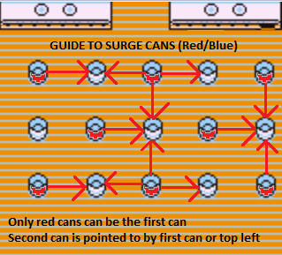

10UB after manip,RB into mash A for gym battle

**Surge:**

* Voltorb: Bubblebeam x2 if 21+ HP, Thrash if <21 HP (Thrash is 74% to kill Voltorb in 1 shot),
* Pikachu: Thrash,
* Raichu Thrash x2
  + If you get confused on Raichu, switch to Pidgey/Spearow or Squirtle (Squirtle if he’s alive) if below 16 HP; if 16+ HP, use HA (if you have any left) or Thrash to finish

## Rocktunnel

Mash text with B and get ™ Thunderbolt

12DB,R,5DB into exit gym

3RB,UB

MENU:pokemon-paras-cut

5U,6L,UB into house

2LB,6UB,2RB, mash A until question into B for talk

Get bike voucher

MENU:pokemon-paras(preset)-dig(1down)

//TODO maybe pokecenter

5DB,3LB,3D,3L,UB into bike shop

2R,5U,RB into A mash B get bike

5DB,L,DB into exit

SAVE

MENU: items-tm24(thundershock, 2up from bottom), 5A- select nido(paras preset)-7A - select leer(2down),A, mash B till learned

MENU: items- helix fossil,select order, 1up from bottom select order

All the way up into bike (bike getup 2A)

//bike allows faster movement in form of faster single input chains and holding speed ofc

6R,DB

MENU: pokemon-select paras(is on nido because of thunderbolt)-cut

2D, RB, UB,LB,4U,RB

MENU: pokemon-select paras(preset on paras)-cut

RB,DB, SAVE

A for trainer battle 4thrash girl

**4-Turn Thrash Girl**: Use thrash and hope for a 4-turn thrash. If you get a 3-turn thrash, use HA or Thrash to finish. Hitting yourself deals 13 damage.

L,2DJ,RB,U,RB,D,RB,UB into trainer battle

**Bug Catcher:**

* Caterpie + Weedle + Venonat: Thrash x3

UB,2L,2U,RB,UB,RB,DB(with DJ),11R,DB(withDJ),RB,DB,LB,UB,RB, UB into rock tunnel

### Rock Tunnel

MENU: item-repel(2up from bottom)

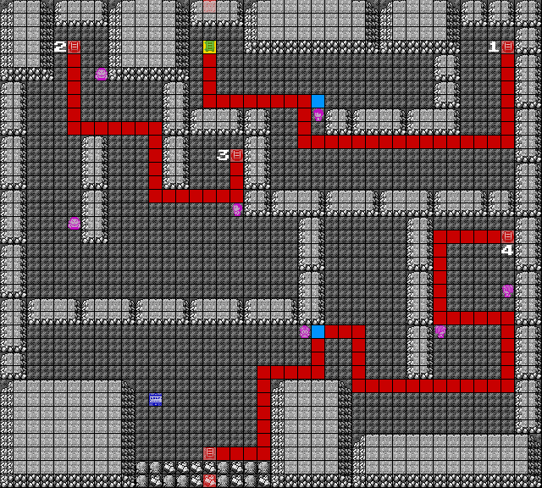

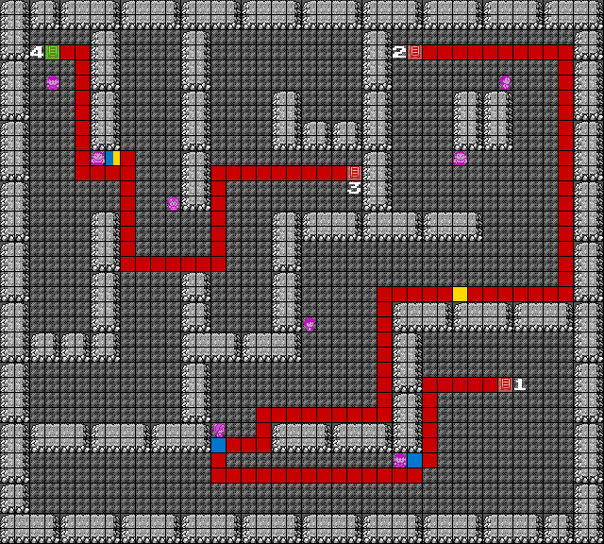

4DB,7R,DB into trainer battle

**Pokemaniac**:

* Cubone: BB,
* Slowpoke: TB

2D,RB,UB into stairs

LB,6D,LB into trainer battle

**Pokemanic 2:**

* Slowpoke: TB

12L,UB into SAVE into mash A for trainer battle

**Rock Tunnel Oddish Lass:**

* Oddish + Bulbasaur: Thrash x2-3
* Oddish is a 55% range to kill in 1 shot with Thrash. Just mash Thrash troughout the fight until you win. Oddish’s Absorb does 5 damage. (If dmg hit its all good).

RB,2U,RB,8U,RB

MENU: item-repel(2up from bottom)-3A, close menu

UB,D,LB into stairs

6D,RB,5D,RB,UB into stairs

LB, 6D,LB,6U,LB into trainer battle

**Hiker**:

* Geodude: BB,
* Geodude: BB,
* Graveler: BB

MENU: item-repel(2up from bottom)-3A, close menu

L,UB,D,LB (second repel just like first here at UB,D,LB) into stairs

LB,DB,RB,5D,LB,4U,LB into mash A for trainer battle

**Jr. Trainer Female:**

* Meowth + Oddish + Pidgey: Thrash x3

DB,4L,DB,LB into exit

## Fly

RB,DB,LB, mash A for repel textbox

DB(with DJ),LB,DB,LB,D,LB,R,DB,LB into trainer battle

**Gambler:**

* Growlithe: BB,
* Vulpix: Thrash
  + Vulpix: Quick Attack 8-10 (12-15 crit)

LB,R,UB,LB,U,11L,DB,L,DB,13L,UB,2L,UB into house

R,UB into stairs

MENU:item-bicycle

DB,25L into A mash for hidden elixir

LB into stairs

DB into exit

MENU:item-bicycle

3R,6U,4L,UB,LB,4D,4L,UB into celadon mart

### Celadon Mart

SAVE

4UB,4LB,UB into stairs

4L,D,LB into shop

2A,3D, 5A into buy sound (TM07 Horn Drill), close shop

2D,3L,UB into shop

2A,3down,A, 9up (quantity10), 4A (10superrepel)

A,2up(quantity3),4A (3 superpotion) close shop

3R,3UB,8R,UB into stairs

4L,UB into stairs

2L,3D(trainer blocks)5L,DB into shop

7A (pokedoll), close shop

5R,3UB,6R,UB into stairs

4L,UB into stairs

3L,UB into shop

2A,down,A into sound A ( soda pop)

#### Rockslide Girl

3R,UB into stairs

UB into instant transition LB,

Test D mashA, L mashA and hope she runs in your direction

Mash A till get TM48 Rockslide sound, start mashing B

Get out of the room based on your position

If you dont get her with D and L, reset the room and repeat

With f.e. RB,U,8R or RB,U,RB,2L,UB or improvisations, same with getting out afterwards

If you know where you are: RB,U,5R,UB into 3A into sound A ( fresh water)

If not reset room again and 3L, UB out of entrance

4LB,3D,3L,UB into shop

3A,10up,4A (11Xacc)

1up from bottom,A,1up,4A (2XSpecial)

A,4up,4A(5XSpeed), close shop

4L,4UB into elevator

2RB,2UB, 2A for floor1,

L,3DB, into exit

R,6DB into exit mart

Bike, LB,4D, 8L,UB

MENU:pokemon-paras-cut

2U,LB,4U,LB into house

8LB into exit

8LB,2D,3L,UB into fly house

3UB into mash A till receive sound for HM02 Fly

4DB into exit

MENU: item(preset on pokemon), 6up (TM48),5A,choose nido(preset on paras), 7A,1down (rockslide for HA)

MENU:item(preset item), one up from bottom(HM02),5A, choose pidgey/dux/sparrow

(preset on nido), just learn it with 1A or forget some random attack

MENU:item-x acc(4up),select,ssticket(2down),select,1down(full restore), select 2up(x speed),select, 1up(x special),select,4down(HM01), select, 1down(helix fossil),select, 2down(super repel),select, 2up(super repel), 3A into use

MENU:pokemon(preset on item)-pidgey(preset on pidgey)-2A(fly)-3down(lavender town)

A to confirm

## Pokeflute

11R,UB into poketower

### Poketower

8U,RB into stairs

2LB,4UB,LB into rival battle

**Lavender Rival:**

* Pidgeotto: TB,
* Gyarados: TB,
* Growlithe: BB,
* Kadabra + Ivysaur Thrash x3
  + Pidgeotto: Quick Attack and Gust 7-9 (15-18 crit)
  + Ivysaur: Vine Whip 10-12 (16-19 crit)

Mash text till rival go away sound

LB,4D, LB into stairs

RB,DB,2R,UB,RB,3D,RB into stairs

LB for trainer battle

**Channeler 1:**

* Gastly: Rock Slide,
* Gastly: Rock Slide
  + Rockslide is a 90% accuracy move. If you die, you can attempt to use Paras and dig to kill the second Gastly.
  + Gastly: Night Shade 23, hit-self 14

DB,LB mash A for elixir

R,2U,LB,DB,LB,3D,LB,U,LB,UB,LB,UB into stairs

RB,DB,A for hidden elixir

UB, 9R,DB, LB into full heal

2A(1tb),2L,DB,RB,UB,RB,UB into stairs

UB,LB,UB into trainer battle

**Channeler 2:**

* Gastly: Rock Slide
  + If paralyzed, take healpad

UB,3L,3D,LB into trainer battle

**Channeler 3**:

* Gastly: Rock Slide
  + If paralyzed, take healpad

3L,DB, A for rare candy

DB,4R,DB into unknown fight

Item-7up from bottom(pokedoll), mash text

LB into stairs

R, MENU: item-TM07HornDrill (9up from bottom), 5A,nido,7A,D,mash A till forget sound (HD for rockslide)

UB into trainer battle

**Rocket 1:**

* Zubat x3: TB x3

Mash B until he is gone UB into next battle

**Rocket 2:**

* Koffing: X Acc(2down) + HD,
* Drowzee: HD

Mash B until he is gone UB into next battle

**Rocket 3:**

* Zubat: TB,
* Rattata + Raticate + Zubat: Thrash x2-3

UB mash A for talk till house teleport

L,5UB,RB,mash A for talk till get sound then B

DB into exit

MENU:pokemon-pidgey-fly-1down(celadon),A

## Silph Co.

UB into pokecenter

UB into mash A for heal

DB into exit

Bike, 13R,DB,RB,D,RB into house

RB into talk mash, RB into exit

Bike, 4R, 4D, RB, UB into house

UB,2L,UB,12R,UB into elevator

2R,UB,A,4D,A till arrived,

L,DB into exit (5th floor)

DB,LB mash A for hidden elixir

D,LB,DB,SAVE

mash A for trainer battle

**Rocket:**

* Arbok: Thrash x2-3
  + Arbok is a 2 hit range with thrash. If you get Glared and paralyzed, use a Full Restore after the fight.
    - If you get paralyzed and have no full restore , reset and repeat

MENU: item- full restore(3down) if not used at rocktunnel thrash girl

R into teleport, D,U into teleport

DB,RB mash A for card key

LB, U into teleport, D,U into teleport

2U,LB into mash A to unlock door, LB,DB,3L,U into teleporter

15R,6U,LB mash A to unlock door, LB,2D,LB into teleporter

Maybe SAVE

UB,LB into rival fight

**Silph Rival:**

* Pidgeot: X Acc(2down) + X Speed(1down from xacc preset) + HD,
* HD the rest

Mash B till rival is gone

DB,RB into teleporter

MENU:item-elixir(1down),3A mash B to close menu

LB, DR, RB mash A for trainer battle

**Rocket:**

* Cubone: X Acc(2down) + BB,
* Drowzee + Marowak: HD x2
  + Cubone: Bone Club 25-30 (52-62 crit)

U,RB,UB mash A for unlock

UB into Silph Gio fight

**Silph Gio:**

* Nidorino: X Acc(2down) + HD,
* Kangaskhan: HD,
* Rhyhorn: BB,
* Nidoqueen: HD
  + Nidorino: Horn Attack 14-17 (28-34 crit)

Mash B till he is gone

DB,LB,UB,D,RB into teleporter

2L,4U,RB into teleporter

RB,3U,4R,UB into elevator

RB,UB, A (9down),A

L,DB into exit

8L,DB,LB,3D,RB into A mash for TM26 Earthquake

3D,RB,UB,RB mash A for rare candy

MENU: pokemon-paras-dig(1down)

## SafariZone

Bike, LB,8D,LB (snorlax) // trainer can get in your way

MENU: item-super repel (5down)-3A

All the way down, 3up (pokeflute)-3A into mash for snorlax

Run away from fight

LB into house,

LB into exit

5L,DB,L,DB, U one tile hold B, 3Rinto A for rare candy continue to hold right till RB with hold B

Release B for 12 beats, one tile left with B, let go till DB, RB with B,15D,3L,R, A for PP up, hold B R into Wait till DB after getting PP up

//somewhere getting down there also the repel expires so press A for that

4L,DB till DJ, DB, RB into house

RB into exit

bike

MENU: item-1up-3A(PP up on HD), 1D,2A

1up from bottom-TM26 Earthquake-mash A until forget sound into B mash to close menu

//EQ for thrash

RB,DB,15R,UB

MENU:´pokemon-paras-cut

2U,2L,UB into cut again

UB,2R,UB into safari zone

### Safari Zone

UB into mash A into B after get sound, UB into exit

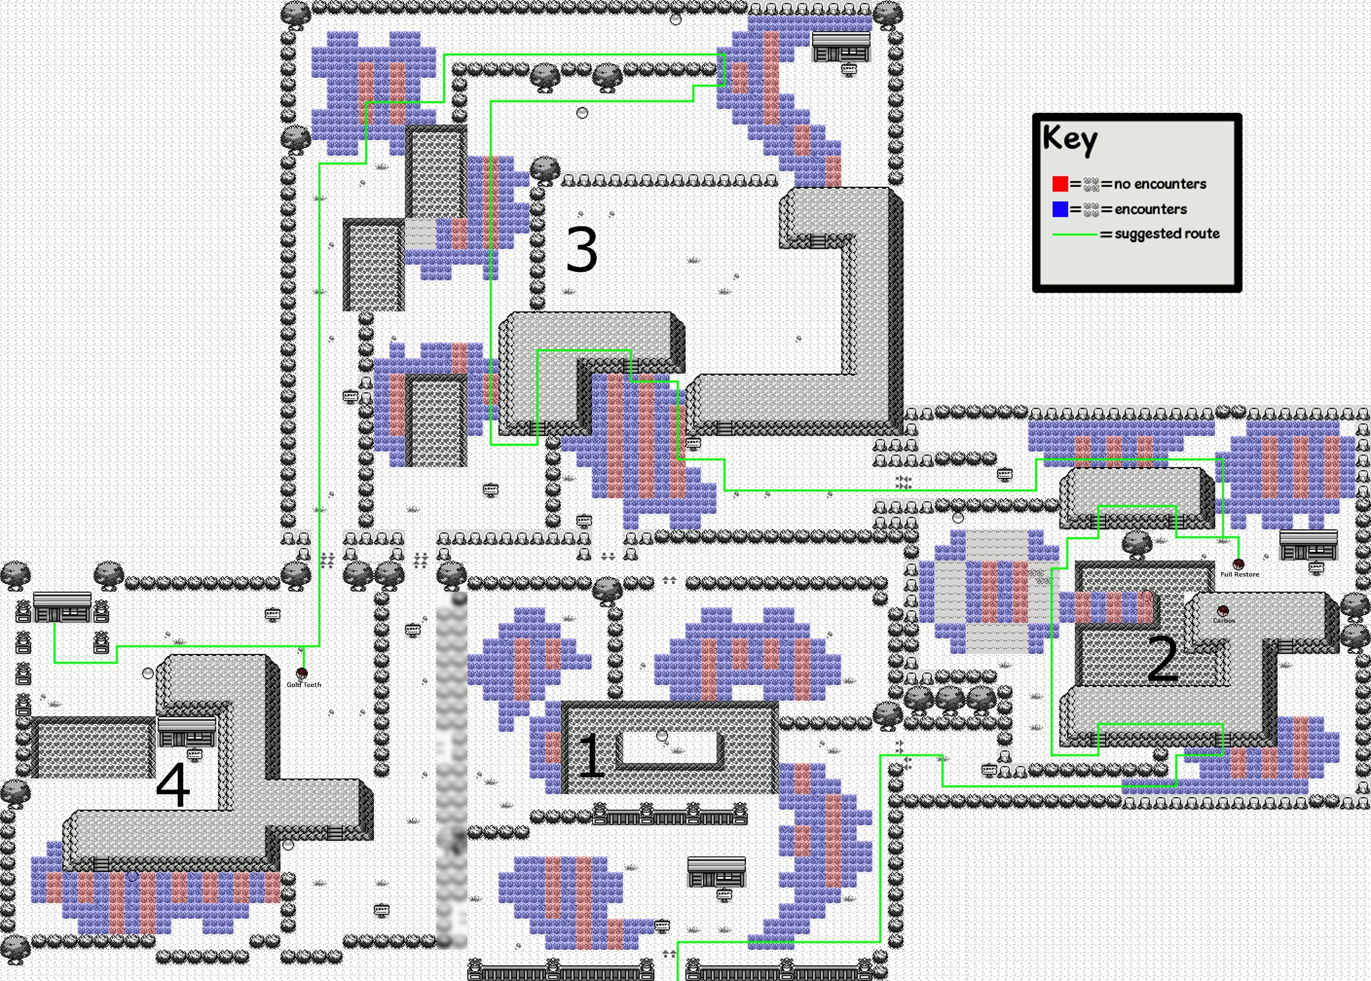

bike

SAVE

MENU: item- super repel(5down)

2U,RB,UB,RB into area 2

DB,20R,UB,LB,R,DB,3L,UB,D,3R,2U,5R,2D,4R,DB mash A for full restore

6U,LB,R,DB,LB into area 3

LB,4R,UB,LB mash A for Repel text

DB,R,2D,3L

MENU: item-superrepel(already preset just mash A)

UB,D,15R,UB,D,LB,R,DB into area 4

7D,LB into mash A for gold teeth

2U,LB,D,4L,UB into house

R,UB mash A for talk, get HM04 Surf

DB into exit

MENU:pokemon-paras(already preset)-dig(1down)

## Koga (Gym4)

SAVE

MENU:pokemon-pidgey(preset on paras)-fly-2down for fuchsia city

14L, UB into gym

U,RB, UB into trainer battle

**Juggler 1:**

* + Drowzee + Drowzee + Kadabra + Drowzee: EQ x4

SAVE

UB,LB(perfect repel),DB,2R,DB,L,DB into trainer battle

**Juggler 2:**

* + Drowzee: EQ,
  + Hypno: EQ+TB
    - Hypno: Confusion 45-54 (83-95 crit), Headbutt 12-15 (26-31)

2D,3R,DB into mash A for koga battle

**Koga:**

* + Koffing: EQ,
  + Muk: EQ,
  + Koffing: EQ,
  + Weezing: Elixer(1down) (if no turn 1 Selfdestruct, stall using only 1 X Acc, then switch to BB or the Pokeflute; if you use an X Acc to stall on Drowzee, don’t use one here since buying 11 only gives you 1 extra)
    - **Koga’s Self Destruct does 79-94 damage**

**// maybe implement redbar? Not worth it...**

Mash text get TM06

3L,UB,RB,UB;LB,UB,RB,DB,4L,DB into exit

## Erika (Gym5)

SAVE

MENU: item- tm06(1up from bottom)- toss-5A (continue mash for bike)

MENU: item- rare candy(3)(5up from bottom)-select nido(should be nido preset), mash a for 3 lvl ups into B mash to close menu

bike,RB(with RJ),2D,6R,UB,3L,UB into house

2L,UB mash A for talk into B after get sound (walk after second)

2R,DB into exit

MENU:pokemon-pidgey-fly-pallet town(mash A for first town)

2L,DB,RB

MENU: item-superrepel(5down)-3A

All the way down-2up(HM03 Surf)-5A-squirtle(preselect on pidgey),A into B mash to close menu

MENU:pokemon-squirtle(preset mash A)-surf

https://i.imgur.com/gxXqCRq.png

DB, L, DB into R,DB after 5+ tiles

L,5D,R onto land

2R,UB into mansion

### Mansion

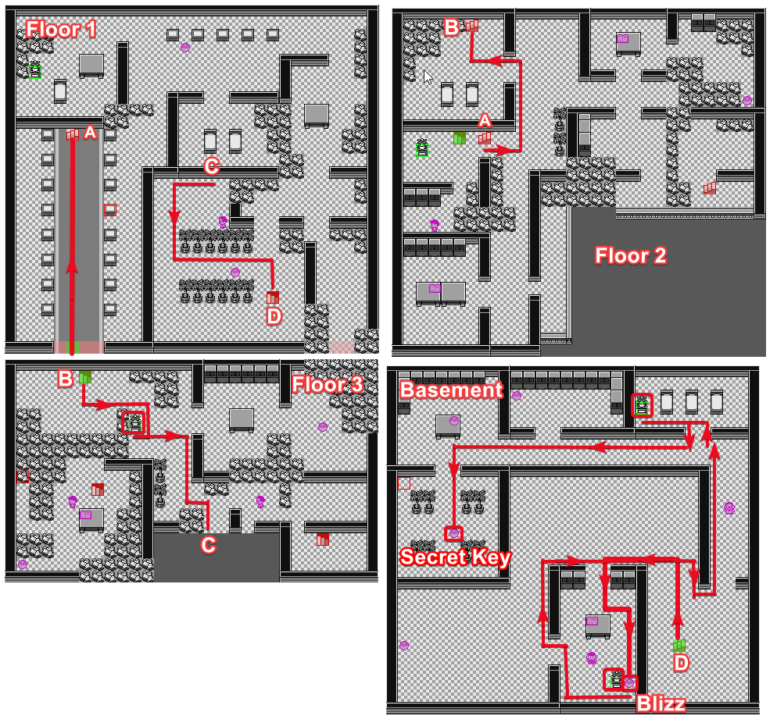

UB into floor2

5R,6U,4L,UB into floor3

RB,DB,LB,UB mash A for switch (3A)

RB,DB,2R,DB into floor1

LB,

MENU: item-super repel(just mash)-2A into B

6D,9R,DB into basement

7U,6L,DB,RB,DB mash A for item (Blizzard),

SAVE

MENU:item-2up from bottom(HM04 Strength)-5A-squirtle(just mash preset on squirtle), mash A till forget sound then 1B after confirm sound

MENU:item-1down(TM14 BLizzard)-5A-nido(preset on squirtle,1up)-7A-3down-A till forget sound into B mash (blizzard over bubblebeam)

DB,L,UB mash A for switch(3A)

LB,4U,2L,7U,RB,3D,2R,

UB,L,2U,LB,UB mash A for switch(3A)

4R,DB,LB,4R,DB mash A for secret key

MENU: pokemon-paras(preset on nido)-dig(1down)

### Gym

Bike(preset), 4L, DB, U,LB(A for repel text),DB,L,DB,10R,DB

MENU:pokemon-paras(preset on paras)-cut

DB,LB,3R,UB,RB,D,RB,UB into gym

LB,UB,RB,2U,LB,6U,RB into CUT (pokemon menu mash with preset)

SAVE

RB into trainer battle

**Beauty:**

* Exeggcute: Blizzard (Blizzard again if you miss)
  + Use the Pokeflute if put to sleep

R,UB mash A for erika battle

**Erika:**

* Victreebel: EQ,
* Tangela: Blizzard,
* Vileplume: EQ

Mash B get TM Megaabsorb

R,DB,CUT(nido preset),DB into exit

MENU:pokemon-pidgey(paras preset)-fly-2down(cinnabar island)

## Blaine (Gym6)

MENU:item-TM21(1up)-toss-5A(mash A into bike)

7R, UB into gym

UB,2R,4U,LB,UB

Q1: Mash A till right sound into mash B till door open

RB,UB,RB,UB,LB,D,2L, UB

Q2: A into mash B till door open

DB,RB,4D,LB,UB

Q3: A into mash B till door open

DB,RB,4D,LB,UB

Q3: A into mash B till door open

DB,LB,UB

Q4: A mash till right sound into B mash for door open

RB,UB,RB,4U,LB,UB

Q5: A into B mash for door open

RB,UB,RB,4U,LB SAVE mash A for Blaine battle

**Blaine:**

* Growlithe: X Acc(2down) + EQ (use HD if he Super Potions on turn 1),
* Ponyta + Rapidash + Arcanine: HD x3

Mash B for talk get ™

MENU:pokemon-paras(nido preset)-dig(1down)

## Sabrina (Gym7)

MENU:items-TM38(1up)-toss-5A mash into bike

13R,DB,RB,D,RB into house

RB into exit

Bike, UB,RB,UB,RB,UB,4L,UB into gym

SAVE

3R,UB into teleporter

3L,2U,LB into teleporter

L,DB,LB into teleporter

DB into teleporter

3U,LB mash A for sabrina battle

**Sabrina:**

* Kadabra + Mr. Mime + Venomoth + Alakazam: EQ x4

Mash B for text

MENU:pokemon-paras(nido preset)-dig(1down)

## Giovanni (Gym8)

//can heal here for no superpotion setup

MENU:pokemon-pidgey(paras preset)-fly-1up(virdania city)

MENU:items-TM46(1up)-toss-5A(mash for bike)

Bike

4L,UB,2D,RB,U,RB,5D,3L, UB into gym

2L,UB,L,UB,2R,UB into trainer battle

**Cooltrainer:**

* Rhyhorn: EQ

U,LB,DB,LB,SAVE, UB into trainer battle

//can heal with an superpotion before(10up)

**Blackbelt:**

* Machoke: X Acc(2down) + HD,
* Machop: Blizzard,
* Machoke: HD
  + Machoke: Karate Chop 12-15 (25-30 crit; he is favorable to crit), Low Kick 7-9 (15-18)

DB,RB,UB,2R,DB,LB,DB,RB,DB,2R,DB into exit

UB into gym again

2L,UB,L,UB,2R,UB,LB,DB,LB,UB,3L,DB,LB,UB,R

MENU:item-elixer(1down) mash A for nido till get sound then mash B to close menu

SAVE

mash A for giovanni battle

**Giovanni:**

* Rhyhorn: EQ,
* Dugtrio: EQ,
* Nidoqueen: EQ,
* Nidoking: EQ,
* Rhydon: Blizzard (+Blizzard)

Mash B for talk,

DB,RB,2U,3R,DB,RB,UB,3R,DB,LB,DB,RB,DB,2R,DB into exit

## Elite 4

MENU:items-™Fissure -toss-5A (A mash for bike)

MENU:items-superrepel(5down)-2A into B,

Bike, DJ,LB,DB,LB,D,LB,3D,4L,UB,LB into rival battle

**Victory Road Rival: //fuck strats just HD everything AFTER PIDGEOT and heal before lorelei**

* Pidgeot: X Acc(2down) + X Speed(1down from xacc) + Blizzard (+Blizzard)(use TB to finish if only 1 Blizzard left),
* Rhyhorn: Blizzard,
* Gyarados: TB,
* Growlithe: EQ,
* Alakazam: EQ,
* Venusaur: HD

Mash text till go away sound

LB, 7D(including DJ),LB,UB,9R,UB,3L,UB into victory road

UB into mash text,UB into exit

bike,UB into mash text,UB, 7R,UB,5L,UB,R,UB into mash text, UB

MENU:pokemon-squirtle(nido preset)-surf(1down)

UB into 2x mash text,UB,

MENU: item-superrepel(5down)

LB,UB,9R,UB onto land, bike

UB mash text,7U,7L,UB into mash text

UB,2L,UB into victory road cave

### Victory Road

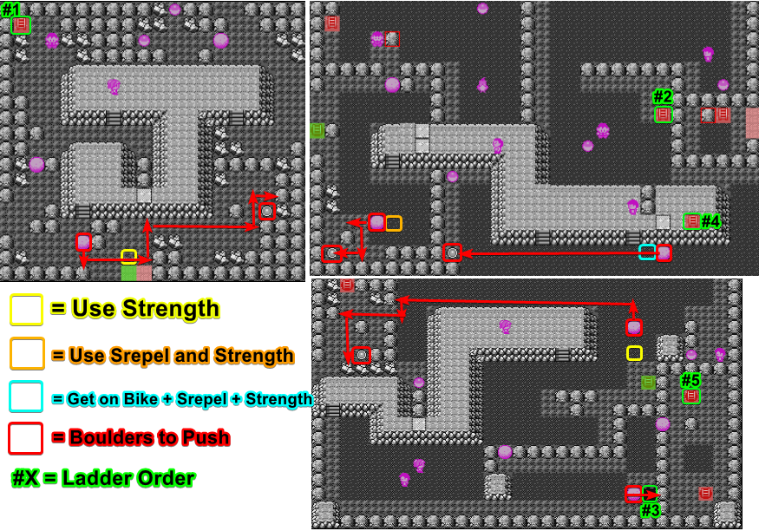

MENU:pokemon-squirtle(preset)-strength(first)

U,4L,UB,RB,DB, 1rock

LB,DB,RB,4rock,DB,RB,UB, 2rock,L,UB,RB,7rock

DB,RB,UB,2rock,2L,UB,RB,1rock,UB,RB,DB,1rock onto switch

L,3D,LB,2D,3L,UB,3D,RB, UB,LB,DB,2R,DB,LB

//MENU:item-superrepel(5down)-2A or whenever it is over with the first one

U,LB,UB,LB into area2

DB,RB,4D,2R,D

MENU:pokemon-squirtle(preset)-strength

L,1rock,U,2L,DB,2rock,R,DB,LB,2rock onto switch

U,2R,UB,RB,DB,R,2D,RB,UB,6L,UB into area3

MENU:pokemon-squirtle(preset)-strength

L,UB,2rock,R,2U,LB,16rock,UB,LB,D,1rock,R,2D,

LB,4rock,LB,UB,LB,DB,3rock,LB,2D,R,1rock onto switch

U,RB,UB,RB,U,13R,

MENU: items-superrepel(preset)

5D,3L,2U,LB,DB,LB,UB,LB,DB,R,DB,15R,U,RB,1rock,RB into pit

Bike, strength, DB,2R,UB,LB,14rock

4R,2U,RB into area3

UB,D,LB into area1

RB into exit

RB,UB,LB,2D,2L,UB,L,UB (mash A for repel text),LB,UB into elite4 prep

### Lorelei

4U mash A for heal

4L,UB,5R,UB into lorelai

SAVE

R,UB mash A for lorelai battle

//wait a bit until music starts for auto walk

**Lorelei:**

* Dewgong: Swap to Pidgey/Spearow(2down in pkmn), let it die,(mash B into 2up) and swap back to Nidoking. Then, X Acc(2down) + HD, then HD the rest

### Bruno

Mash text with B

MENU: items-elixer(1down)-3A(nido) mash B to exit menu

L,UB into next room

R,UB mash A for bruno battle

//wait a bit until music starts for auto walk

**Bruno:**

* Onix: X Acc(2down) + Blizzard,
* Hitmonchan: HD,
* Hitmonlee: HD,
* Onix: Blizzard,
* Machamp: HD
  + Onix: Slam 17-20 (35-42 crit)

### Agatha

Mash text with B

L,UB into next room

SAVE

RB,UB mash A for agatha battle

//wait a bit until music starts for auto walk

**Agatha:**

* Gengar: X Special(4down) + EQ,

//confuse ray is bad, hypnosis is worse(sleep)

* Golbat: Blizzard,
* Haunter: EQ,
* Arbok: EQ,
* Gengar: EQ

//reset if you die , just get through somehow

### Lance

Mash text with B

SAVE

MENU:item-elixer(1down)-3A(nido) //all elixers gone, everything count-1

MENU:item-full restore(8down)-3A(nido)

L,UB into next room

UB mash A for lance battle

//wait a bit until music starts for auto walk (door close sound)

**Lance:**

* Gyarados: X Special(3down) + TB,
* Dragonair: Blizzard,
* Dragonair: X Speed(2down) + Blizzard,
* Aerodactyl: TB,
* Dragonite: Blizzard (TB if you are out of Blizzards)
  + Gyarados will use Hydro Pump and does 108-128 damage. A Hydro Pump crit = dead. If it misses, continue as normal and don’t heal for Champ.

## Champ

Mash B for text

//if hit by hydro pump: MENU:items-full restore(2down)-3A //count -1

//if no full restores:items-(4down)super potions on nido to heal it to full health,superpotion count(bought3)

L,UB into champ fight

**Champ:**

* Pidgeot: X Acc(1down) + X Speed(1down, right afterwards from x acc preset) + HD,
* HD the rest

Mash text till 3rd music change into TIME

EZ GG WP NO RE

# Notes

* General Fighting: mash B for textboxes so you are back at fighting menu without losing track for mashing attacks and random menus
* MENU resets after fights
* Keep count how many items you use! Especially pokeballs and potions for menu order until surge
* Bs dont affect repels!
* NuggetBridge and other places: swap out after sandattack causes exp loss! Swapped pokemon needs to die after switching else the run is dead
* Probably save after each major split for safety
* Started 02092018
* Repels are gone after SQ Resets
* Finished 08.10.2018 with a time of 3:14:39

Fighting notes/pictures copied and modified from:

<https://docs.google.com/document/d/1RRS2ViX168hekFXjw5b-vWnBqZsafo9w7bSe38cFZ9o/edit>  
Shoutouts to all creators!

* Potential SAVE spots: Brock, Shorts guy (2nd fought trainer route 3), 4-Turn Thrash Girl (First trainer fought after getting Bike), Rock Tunnel Oddish (3rd fought trainer in rock tunnel), Blackbelt (2nd fought trainer in Gio’s gym), Agatha, Lance, Champ